2/28/2020

Rohit Suseel K

RXS190016

Maps in Tableau

Assignment 6

1.Provide the screenshot of your map:

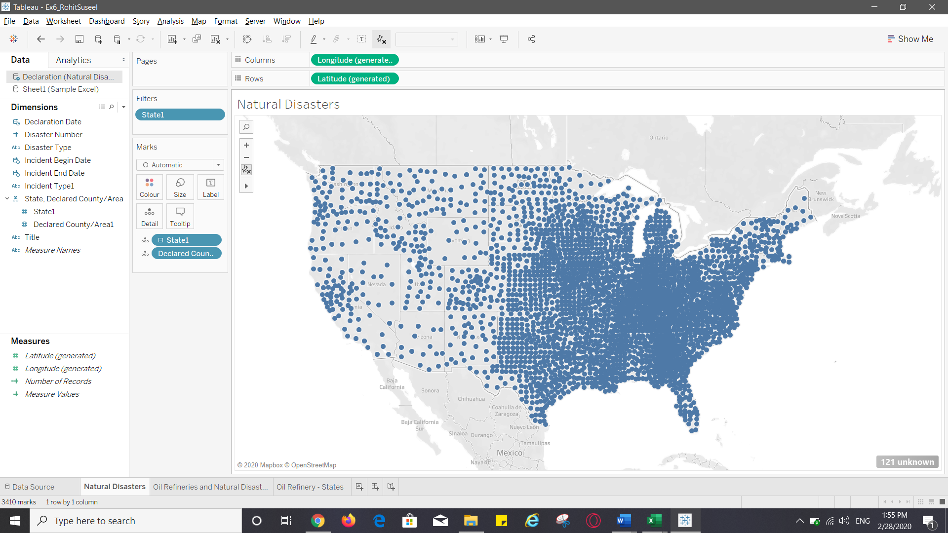

2. Place the screen shot of your map displaying ‘Number of Records’ as tooltip along with other tooltip fields:

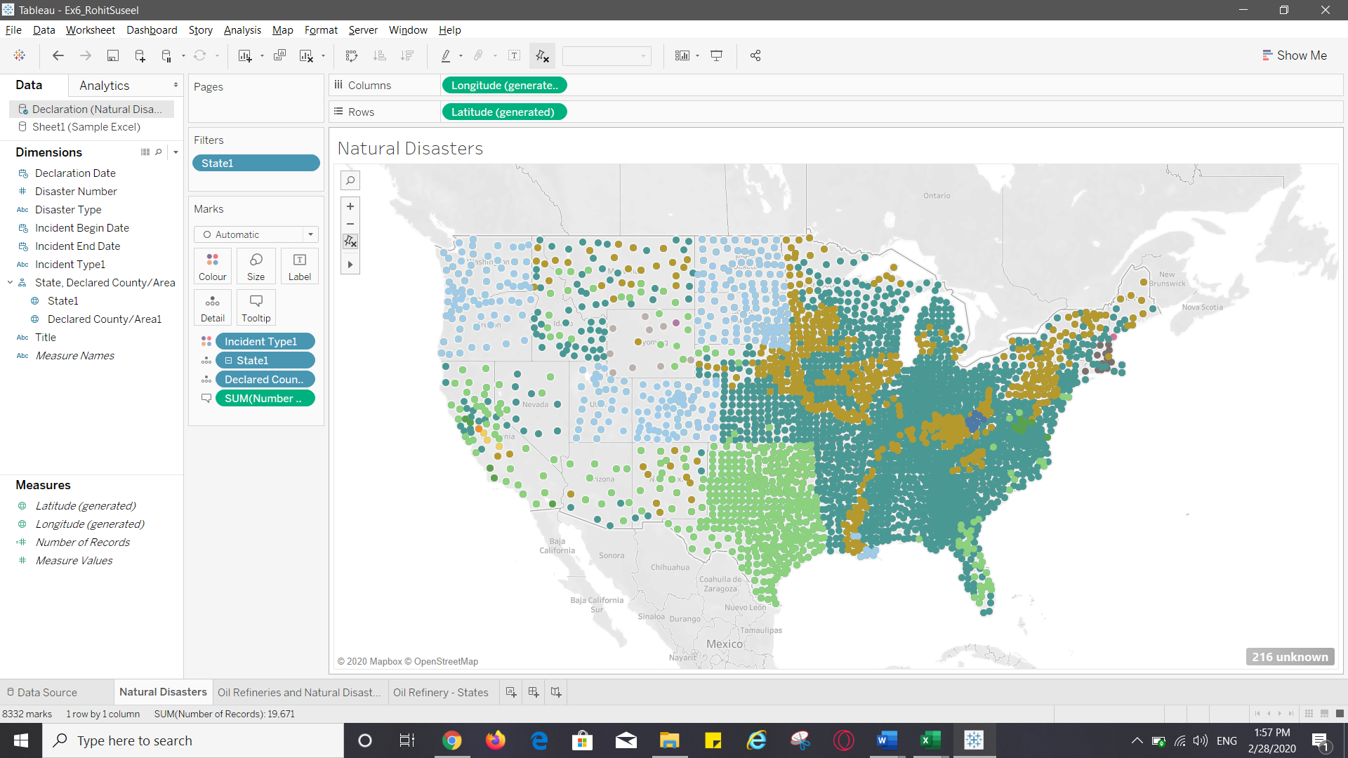

3.Add ‘Number of Records’ to Size card

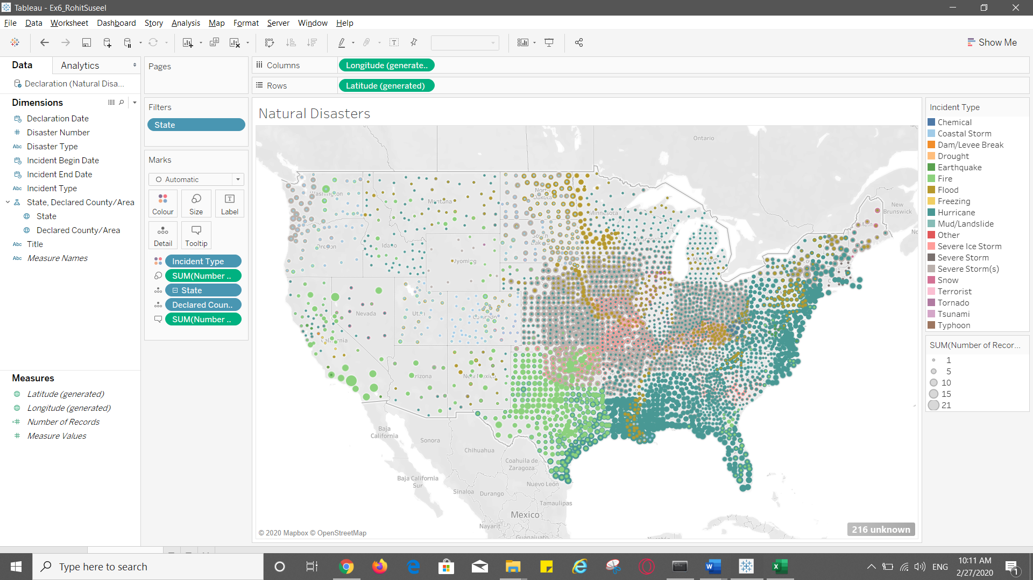

4. Place the screen shot of your workbook displaying ‘Incident Type’ and ‘State’ as a quick filter

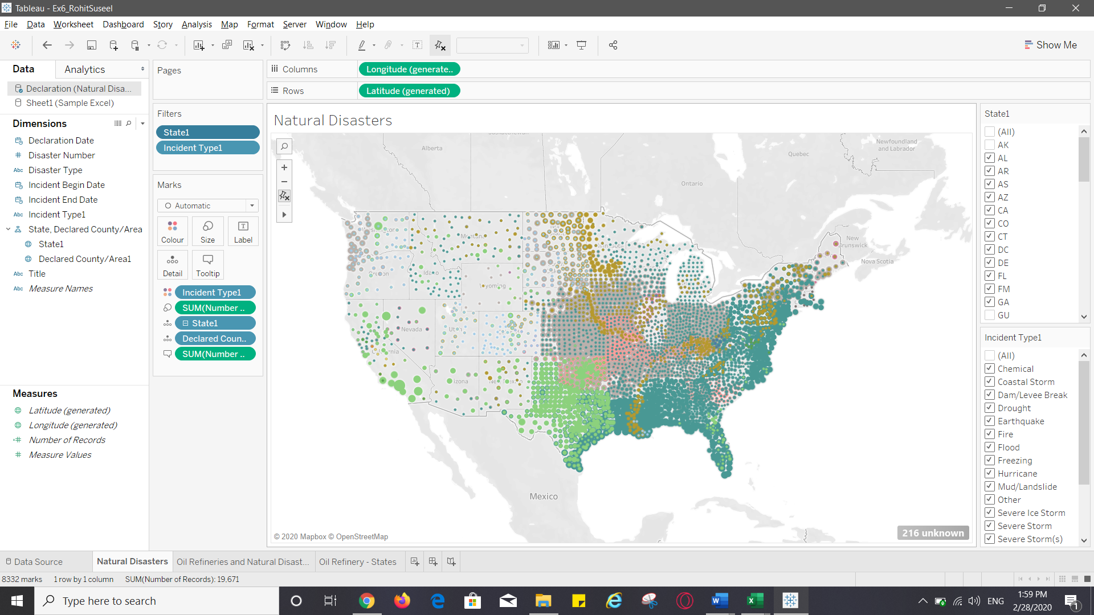

5. As per your map which is the most prevalent disaster in Texas and Alabama?

Hurricanes in Texas(1057 incidents) and hurricanes in Alabama(287 incidents) are the most prevalent disasters.

6.Why can’t you see Alaska and Hawaii on the map?

We filtered out AK and HI by adding state filter.

7.How have we visually encoded different disasters, select your answer from below given choices?

1. Using Label
2. Using Size
3. Using Color

The incident type is color encoded

8.How have we visually encoded number of disaster incidents in a county?

Number of disaster incidents in a county is size encoded.

Part 2: Visualize all refinery locations for one ‘Energy Company’ - ConocoPhillips

Provide the name of all the refineries (the ones you have selected) and the associated counties and states in which they are present.

|  |  |
| --- | --- |
| Name | State |
| ConocoPhillips Kuparuk Refinery | Alaska |
| ConocoPhillips Rodeo San Francisco Refinery | California |
| ConocoPhillips Santa Maria Refinery | California |
| ConocoPhillips Wilmington Refinery | California |
| ConocoPhillips Wood River Refinery | Illinois |
| ConocoPhillips Alliance (Belle Chasse) Oil Refinery LA USA | Louisiana |
| ConocoPhillips Westlake Refinery | Louisiana |
| ConocoPhillips Billings Refinery | Montana |
| ConocoPhillips Linden Refinery | New Jersey |
| ConocoPhillips Ponca City Refinery | Oklahoma |
| ConocoPhillips Trainer Refinery | Pennsylvania |
| ConocoPhillips Borger Refinery | Texas |
| ConocoPhillips Sweeny Refinery | Texas |
| Conoco Philips Ferndale Refinery | Washington |

9.Place the screen shot of your workbook displaying ‘Refineries’ and ‘Disasters’ on map

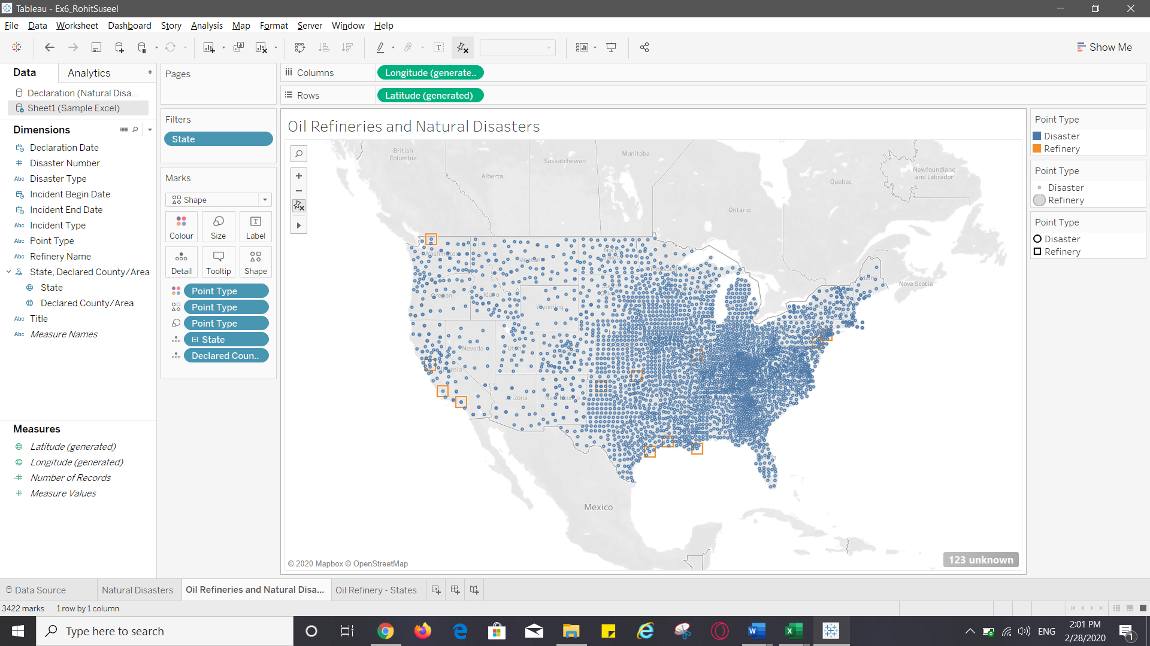

10.Place the screen shot of your workbook displaying disasters and refineries in new color and shape

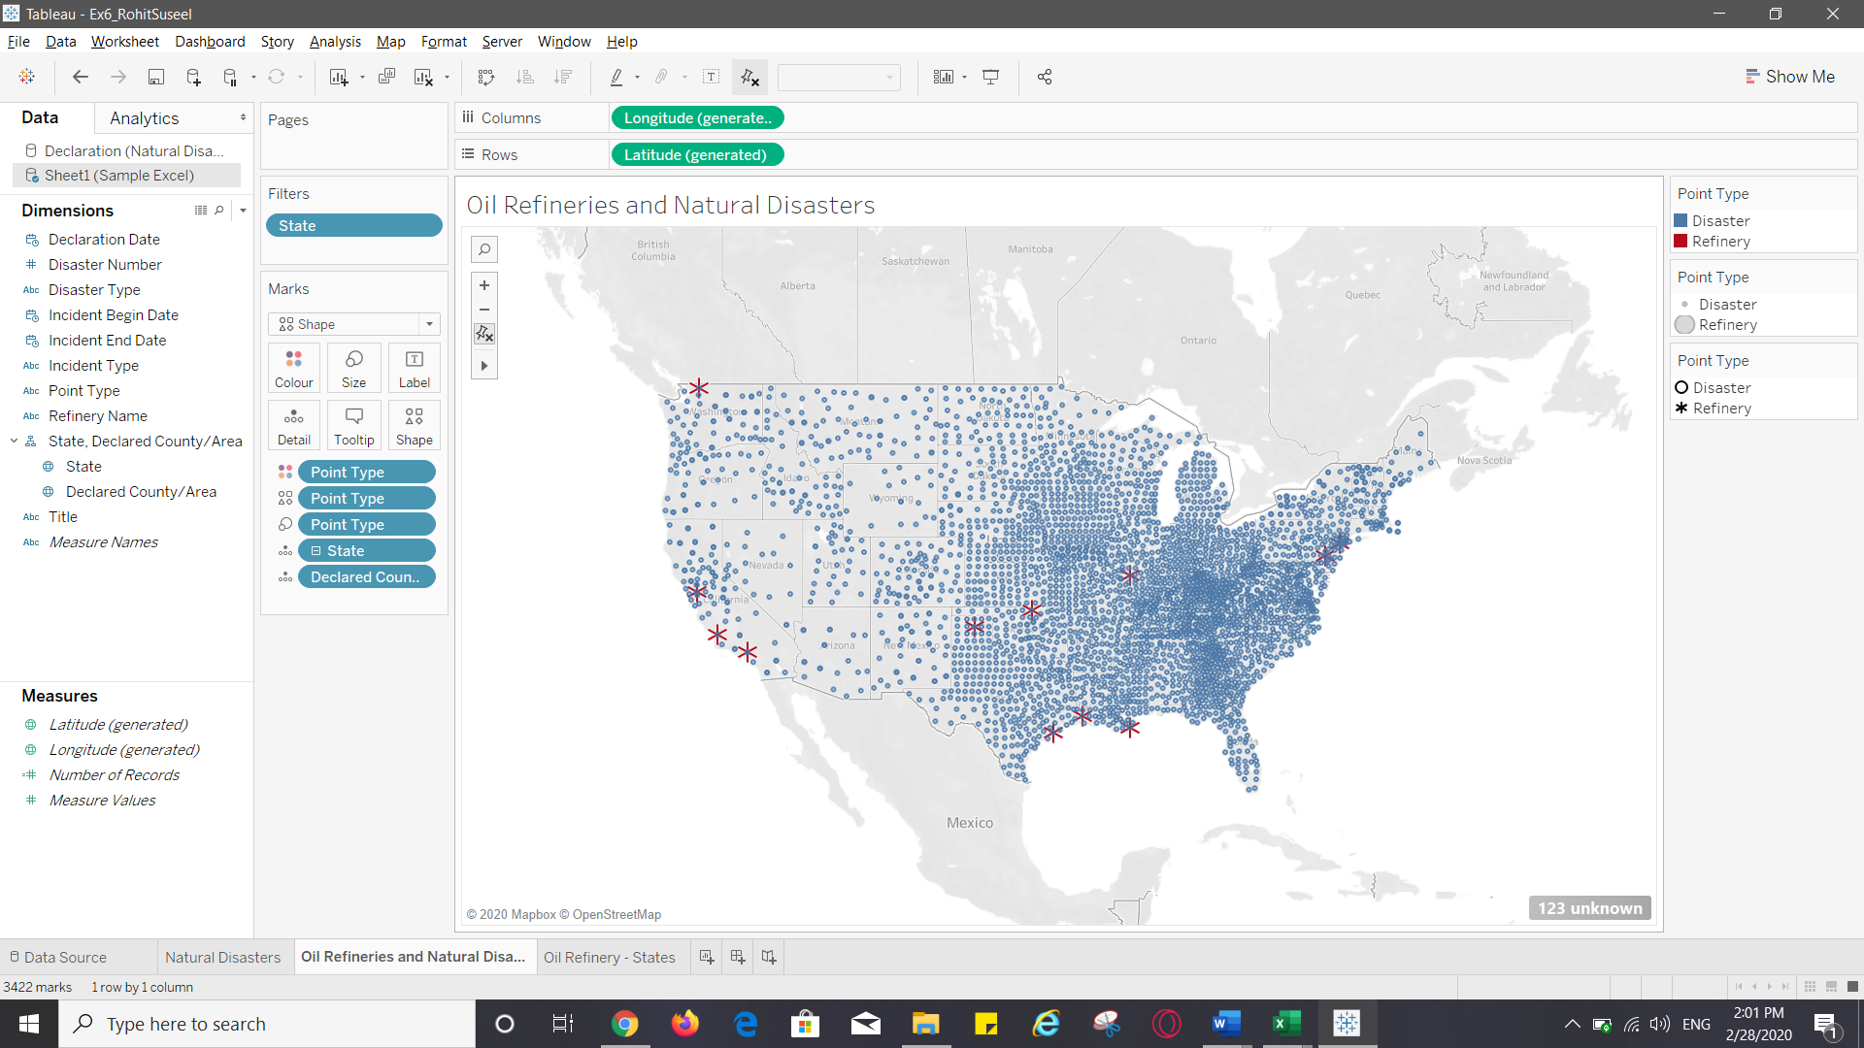

11.Name all the states in which your selected Energy Company has refineries?

ConocoPhillips company has refineries in the following states:

|  |
| --- |
| Alaska |
| California |
| Illinois |
| Louisiana |
| Montana |
| New Jersey |
| Oklahoma |
| Pennsylvania |
| Texas |
| Washington  **Part 3: Visualize refinery states**  12.Place the screen shot of your map |
|  |
| 13.Place the screen shot of your workbook displaying disasters (with different colors) and oil refineries |
| 14.For at least 2 states list all disasters that are impacting that state  Texas: Severe storm, Hurricane and Fire  California: Dam/Levee Break, Earthquake, Fire, Flood, Freezing, Hurricane, Severe Storm, Tsunami  **Part 4: Find top 4 disasters impacting refinery locations**  15.After creating all the four calculated fields paste the screen shot of you ‘Measures’ pane:    16. Which disaster is ranked 1st? Paste the screenshot with tool tip details  Hurricane is ranked first. |
| 17.Paste the screen shot of your multi-map? |
| 18.Paste the screen shot of your multi-map showing labels? |
| 19.Why all the calculated fields got added to Measure pane and not to dimension pane?  Because we created the calculated fields by right clicking on the measure pane. If we need the calculated fields to be added to the Dimension pane then we should right click on Dimension pane and create the field.  Calculated fields in Measure pane calculates quantitative data as in numbers whereas calculated fields in Dimensions pane calculates quantitative data.  **Part 5: Create a Story in Tableau using Rhetoric**  20.Paste the screen shot of your story in Tableau. Make sure to include screen shots of all the data points. |
| 21.Explain which rhetoric was used and how you used it. Why does the Rhetoric you picked, fit the visualization?  The rhetoric used here is ethical. The reason why it is used is that there is an alarming issue at hand regarding the locations of the refineries. These refineries are laid as ticking time bombs in areas which are prone to natural disasters. This calls for an ethical responsibility from the side of the company in question to exert caution while choosing where to plant their refineries. And device a fail proof mechanism in areas where there are chances that the safety of the refinery may get compromised.  The insights described in the visualization depicted in the story clearly has ethical implications on the society and that is why I think an ethical rhetoric would suit the story much better. |
|  |
|  |
|  |
|  |
|  |